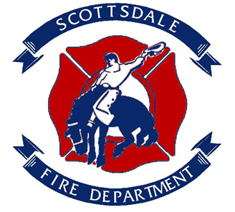
Scottsdale FIRE DEPARTMENT
FIGHT AGaINST CANCER PLEDGE
Recent studies show that 1 in 3 active duty fire personnel and 2 in 3 retired fire personnel will be diagnosed with cancer. The stress and uncertainty of such a diagnosis affects not only the member, but their entire family. With that in mind the Scottsdale Fire Department would like to make every effort to support our personnel and their extended family in any way possible. As an organization, we can do our part to help fight cancer. There have been simple yet effective preventative measures that can be taken to help reduce the risks of cancer. This pledge is simple, but meaningful.

I pledge to take these simple preventative steps to help the fight against cancer:
- I pledge to wear and use my SCBA from initial attack to completion of overhaul.
- I pledge to do a gross field decontamination of my PPE to remove as much of the bulk contamination as possible while still at the fire scene.
- I pledge to use Wet-Nap, Action wipes to remove as much soot as possible from my head, neck, jaw, throat, under arms and hands immediately and while still at the fire scene.
- I pledge to wash contaminated clothes as soon as practical. I pledge to shower thoroughly after a fire and change into a clean work uniform.
- I pledge to clean all my PPE including: gloves, hood, helmet, helmet liner, and turnout/bunker gear immediately after a fire to the best of my ability.
- I pledge to exchange my hood after every working structure fire, vehicle fire, training fire, and IDLH environment.
- I pledge to not take contaminated clothes or PPE home or store it in my vehicle.
- I pledge to decontaminate the fire apparatus interior, including my SCBA and other tools used at the fire.
- I pledge to keep turnout/bunker gear out of living/sleeping quarters, and keep heavily soiled gear out of the apparatus cab until cleaned.
- I pledge to make every effort to use sunscreen or sun block on all exposed skin.
- I pledge to complete a personal exposure form after every working structure fire, vehicle fire, training fire, and IDLH environment.
- I pledge to take responsibility for my health by participating in my annual medical examinations to help with early detection of cancer or other life changing diseases.

Participant Printed Name

Participant Signature Date:

